2016

Modern Presentation Software Research Project

Philip Dumaresq

1. Figure 1‑1 presentation software table 5
2. Figure 2‑1 Prezi features 5
3. Figure 2‑2 Prezi document 6
4. Figure 2‑3 prezi slides 7
5. Figure 3‑1 table feature in slideRocket 9
6. Figure 3‑2 something from slideRocket 10

# Contents

1. Executive Summary 1

1.1 Introduction 3

1.2 What is meant by online presentation software? 3

1.3 Where do these products come from? 3

1.4 Who exactly uses this type of technology? 3

1.5 A detailed look at modern presentation software 4

Figure 1‑1 presentation software table 5

2. Prezi 5

Figure 2‑1 Prezi features 5

Figure 2‑2 Prezi document 6

Figure 2‑3 prezi slides 7

2.1 Prezi Pricing 7

2.2 Prezi Compatibility 7

2.3 Prezi Scalability 8

3. SlideRocket 8

3.1 SlideRocket Features 9

Figure 3‑1 table feature in slideRocket 9

Figure 3‑2 something from slideRocket 10

3.2 SlideRocket Performance 11

4. Impress.js and Deck.js 12

5. Why use this software instead of PowerPoint or Keynote? 13

6. Issues related to technology 13

7. Future of technology 14

8. Impact on CS Streams 14

9. Conclusions and recommendations 15

10. Bibliography 16

# Executive Summary

Different presentation software packages were evaluated for their use in small classroom environments such as the ones in Computer Science at Heritage College. The three software packages that were evaluated are Prezi, SlideRocket and two JavaScript frameworks.

Prezi has a large feature set but does not integrate well in teaching due to the time required to create the presentations. It was also found that Prezi could be more distracting than useful in classroom environments because of its focus on more animated slideshows.

SlideRocket also has a large feature set that integrates well into teaching to all sizes of classrooms because it follows a more traditional slideshow look and feel. It is easy to use and allows for simple and quick integration and publishing of previously created PowerPoint presentations. It could be very useful in a hybrid classroom environment where part of the course is taught online because of its easy integration features.

JavaScript frameworks are more advanced presentation packages that are geared more towards the technical aspect of Computer Science. They are very powerful and near limitless in features but require significantly more preparation time than other presentation packages because they have no user interface to work with; the entire presentation must be created manually.

Each of these packages could be integrated in Computer Science at Heritage College. Prezi could be used for student presentations when new topics are being discussed with classmates. SlideRocket could be used by professors to communicate content in much the same way as they already do. It could also be used to make classroom content available online for later viewing and for hybrid courses. The JavaScript frameworks could be integrated in the Web Programming courses to help students learn and apply various Web Programming languages in a visible way.

What is the best online presentation software for use in small college classrooms?

## 1.1 Introduction

The purpose of this research is to evaluate alternative and more modern presentation software to find which one best suits small college classrooms. Three different presentation packages are evaluated to see how they could be used in a small classroom environment such as the one that can be seen in Computer Science at Heritage College. First, popular presentation software Prezi is evaluated. Second, up and coming SlideRocket is evaluated and finally, JavaScript presentation frameworks are evaluated.

## 1.2 What is meant by online presentation software?

When most people think of presentation software they think of Microsoft’s PowerPoint or Apple’s keynote. They are by far the most popular pieces of software to create and present topics of all sorts. The in this paper are alternatives to these. More specifically, they are web-based alternatives that run on modern browsers. They provide a means of releasing presentations on the Internet for viewing by more people with software available on most modern computers.

1.3 Where do these products come from?

The growth of the Internet and the ever-increasing demand for information came many presentations by many people on even more topics. Even more so, technology is being used more and more every day in the classroom to facilitate information sharing and increase interactivity in presentations. Built on the traditional concept of slide shows, PowerPoint and Keynote were seen by many as limited and dull ways to create presentations. The growing popularity of JavaScript and the increase in browser technology allowed people with these concerns to start creating more interactive and less limited presentations.

## 1.4 Who exactly uses this type of technology?

While the technology is still emerging, various universities and colleges have already begun adopting it for their lectures and presentations. For example, the University of Pittsburgh20 recently used Prezi to announce award-winning teachers and various universities such as the University of Regina1 have held workshops for teachers on how to use such technology. There is definitely a push in the educational sector to create more interactive and eye-catching presentations. Even more locally, like at Concordia University21, teachers are encouraged to use emerging technologies for teaching and given online courses on how to do so. Many teachers 8 are using new presentation software to incorporate social media7 into their courses to establish student communication and expand learning.

## 1.5 A detailed look at modern presentation software

In order to gain an accurate perspective on what are the benefits and downfalls of each presentation software, each is analysed on a variety of criteria: ease of learning, ease of use, functionality, price, and compatibility with modern browsers.

The following chart gives a breakdown of the main criteria used for the analysis and gives an overview of the pros and cons of each software.

|  |  |  |  |
| --- | --- | --- | --- |
| *Criteria* | Prezi | SlideRocket | JavaScript Frameworks |
| Free Version | Yes (basic tier) | Yes (basic tier) | Completely Free |
| Education Pricing | Completely Free (Pro, no support & no desktop editor) | About $1000 for 1000 or Free with Google EDU (Middle tier) | Completely Free |
| Ease of use | Moderate | Simple | Advanced |
| Ease of learning | Simple | Moderate | Basic to advanced  (depending) |
| Tutorials Provided | Yes | Yes | Yes |
| Speed of creation | Moderate | Short to moderate | Long |
| Compatibility with modern browsers | Most (requires flash) | Most (requires flash) | Most (Sometimes less features) |
| Mobile | Most (requires flash) | Most (requires flash or mobile app) | Some to most (depending) |
| Style | Free Canvas | Traditional Slideshow | Traditional slideshow and Free Canvas |
| Animations | Automatic | User-Controlled | User-Controlled (advanced) |
| Importing Slides | PDF and images | PowerPoint | --- |
| Desktop Application | PRO | PRO | --- |
| Charts and graphs | Complicated (no graphs, manual editing) | Simple | Not built-in |
| Collaboration | Up to 10 users | Single slide sharing | Not built-in |
| Sharing | Standalone, website embed | Standalone, website embed | Website |

Figure 1‑1 presentation software table

**No table of figures entries found.**

# Prezi

Prezi is one of the more popular web-based presentation software. Prezi has a very light initial learning curve; one can start with a blank presentation or pick from one of the few starting templates and get started immediately. The example templates are a good place to start because they already have a built-in presentation path (series of focus areas that act as “slides” throughout the presentation). This makes getting started very simple because there are already example text areas and images to start with.

However, there is a slight learning curve involved with some of the controls. After about 15 minutes of playing around with the controls, though, they become almost second nature and are rather easy to use.

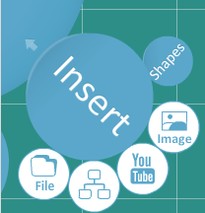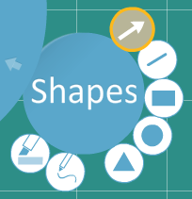

Figure 2‑1 Prezi features

Prezi has a wide feature set; it allows inserting files, charts, YouTube videos, images and shapes. It is also possible to draw on canvas (which is useful to circle something as one would on a traditional blackboard or white board). However the charts are complicated to use and add to because they are not tables; they are simply lines arranged to look like a chart. This means that anything beyond basic one-on-one comparisons are very difficult to manage.

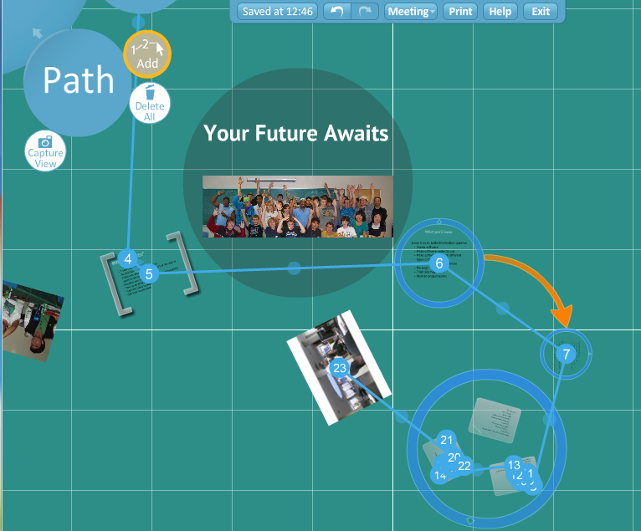

Figure 2‑2 Prezi document

The presentation path menu option is perhaps the most important aspect of the software and was clearly the focus area. It is easy to use and very intuitive. This is the order in which items on the canvas gain focus. It is extremely simple to add focus to an item and to order the different focus areas; simply click on an item and it adds it to the focus area.

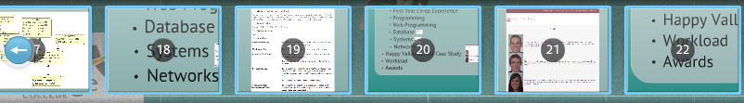

Figure 2‑3 prezi slides

Then simply drag and drop in the order you want things to appear. Unfortunately, it adds all new path items to the end of the path, which can become very tedious when adding new path items in the middle of a long presentation.

Beyond the path, one can focus on specific items during the presentation simply by clicking on them. All the animation is taken care of by the software automatically.

## 2.1 Prezi Pricing

Prezi has three different tiers of pricing. The first tier is the basic free tier and provides a user with all the functionality of Prezi and 100mb of storage. The next tier is the “enjoy” tier and provides a user with basic tier features, the ability to keep content private, branding with your own logo, premium support, and 500mb of storage space. There is an educational license for teachers and students to use, which is equivalent to the “enjoy” tier, without the premium support. The final tier is the “pro” tier and provides users with all the features of the “enjoy” tier, a desktop client for offline creation and presentation as well as 2000mb of space.

## 2.2 Prezi Compatibility

Prezi is compatible with most modern browsers and requires only 1 GB of RAM to run. The only downfall here is that it requires the Adobe Flash plugin to run. This can be overcome, however, by exporting the presentation. This allows the presentations to be run without Adobe Flash. Regardless of this, it runs smoothly and quickly.

While Prezi offers the option to insert drawings and diagrams (including tables of data), it makes it difficult to go beyond the examples that it creates for you. If you insert a table, it inserts a set of lines and text fields that look like a table but really aren’t. This means that if you want to add a new row or a new column to your table, you have to modify the lines manually. This is difficult and makes the comparison of information very difficult.

While Prezi does not offer control over the appearance of transitions between different items in the presentation path, the automatic transitions are very appealing and work well. Beyond this, it is possible to add an animation while presenting by simply clicking on an item that should be emphasized. Prezi will automatically zoom in to this item and it is possible to return to the regular presentation path by continuing the presentation normally.

## 2.3 Prezi Scalability

Prezi works well for any type of group work (up to 10 users). It allows one person to own the presentation but up to 10 people to work on it at the same time. This makes it possible for different people to work on different parts of a presentation. It’s easy to see what anyone else is working on. There is also the ability to present to a group of remote users. This could be used in remote conference calls and is definitely a benefit of Prezi. On the other hand though, it only allows for one person to “own” the document and requires this person to send out new invitations to editors every 10 days. Exporting is available but there does not appear to be a way to import a previously exported presentation into Prezi for editing.

Prezi automatically saves the work you’ve done on a slide. It does this fairly frequently and it ensures that even if you lose connection you can resume right where you left off.

Prezi uses the same keyboard shortcut that the operating system uses to undo or redo something. The keyboard shortcuts are even modified to match the operating system (e.g. CTRL + Z on windows and CMD + Z on Mac). This makes it easy to work with the application and gives the web application a native feel.

Prezi allows for easy integration in a website by simply using the embed code provided. It also allows you to control how users can interact with the presentation. They can be free to zoom or you can force them to use the basic navigation arrows only.

Overall Prezi is a great piece of software and very good for educational purposes, especially given the education tier. It’s easy to use and has a very nice feature set and helps create very attractive presentations.

# SlideRocket

SlideRocket is a more traditional type of presentation software in that it keeps the concept of slides. The idea behind this product seems to be to create a slideshow to put on a website for everyone to see. It also allows for hosting a “meeting” where viewers can see the presentation as you present it. It allows viewing on modern browsers including phone browsers and has an iPad and iPhone native application.

SlideRocket would actually be very useful for a company that wants to provide help documents in the form of slideshow presentations and wishes to gather feedback (pro version only) on these slides and their products. It allows this by integrating survey form items into the slides. As well, it provides analytical information about slide usage (time spent on each slide), which is helpful to indicate problem areas in a slide set.

## 3.1 SlideRocket Features

SlideRocket actually supports importing previously created PowerPoint presentations and converting them into SlideRocket format. This is very useful if a presentation needs to be published after it has been used because it prevents the need to recreate the presentation.

The interesting thing about SlideRocket is that it allows for integration of a lot of different content types. One can integrate images, videos, charts and graphs, tables and even automatically updating twitter searches and stock quotes. The aim here appears to be to keep the information in the slides easy to use, easy to update and in the case of twitter searches and stock quotes, automatically updated. However, it does not support integration of YouTube videos.

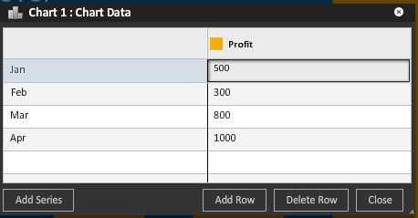

Figure 3‑1 table feature in slideRocket

The charts and tables are one aspect that SlideRocket definitely wins over Prezi. They are extremely easy to insert and use (as well as update). They are very appealing to the eye as well. Chart information can actually be linked to a Google Spreadsheet. This makes it extremely easy to manage the data in the cloud and share it with other people involved.

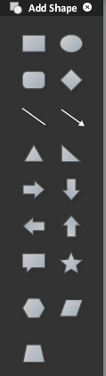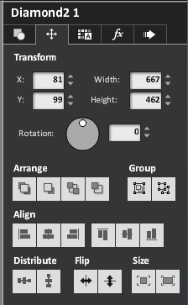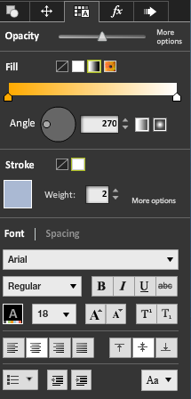

Figure 3‑2 something from slideRocket

Shapes are very easy to input and there is a larger selection of shapes to choose from than Prezi. They are easy to manipulate and style and they have a lot of options to do so. This same styling is available to every item type in a presentation. This is especially useful to customize the appearance of text on slides and to move things around on a slide and gives a lot of control to the user.

The animations available to the creator of a slideshow on SlideRocket are very nice and help focus certain areas of a presentation. This is especially useful when presenting bullet points on a slide separately to emphasize certain key points. If you choose to upload a previously created PowerPoint presentation, it even attempts to keep as much of the animation as possible. Unfortunately, unlike with Prezi, SlideRocket does not allow for “on the fly” animation/focusing of different presentation elements by clicking on them; any animations must be created manually.

## 3.2 SlideRocket Performance

During the evaluation period, SlideRocket was often found to be slower than Prezi. The interface often has to load even when doing something as simple as adding an empty slide to the current presentation. It even appeared quite slow while presenting, with slide changes taking a few seconds to load. This was almost instantaneous with Prezi. However, this was only when a presentation was imported from a PowerPoint presentation. If a presentation was simply created in SlideRocket, it was only slow when adding new slides. However, slide content was extremely responsive regardless. Once a slide was loaded, everything runs smoothly. This does, however, make PowerPoint presentations appear unprofessional, especially when not publishing it to the Internet (i.e. conducting an actual presentation in front of a group) but regular presentations look very nice and professional.

SlideRocket has a basic free account and has education pricing available. It’s more expensive than Prezi (which offers free educational accounts) but does come free if the school is using Google Apps EDU. The free account, however, is only limited in storage space, versioning, offline access and analytics features. The enterprise version does offer enhanced security, which is a must for any company that wishes to use it to do business. The pricing is very reasonable and affordable.

SlideRocket has four plug-ins that can be integrated and used in slides. The quotes plug-in is a plug-in that contains a large database of inspirational and topical quotes that can easily be added to presentations to help emphasize certain points or make references to things people have said. The stock quote plug-in is useful for any presentations that need to contain current stock information (for example; for a company presentation). There is also a Twitter plug-in to integrate a live Twitter feed containing certain words and a word definition plug-in that allows for easy integration of word definitions. There is also a snow plug-in whose sole purpose is to add a snow animation to a slide and isn’t quite useful.

SlideRocket does not automatically save changes to slides (unlike Prezi) but it does save changes separately and will prompt you to recover unsaved changes if you re-open a presentation that wasn’t saved. It would make the experience more natural if it was saved automatically but SlideRocket ensures nothing is lost regardless.

SlideRocket has a number of keyboard shortcuts. They are different from the ones used by the operating system but they work well and are very similar (e.g. CTRL + ALT + S instead of CTRL + S).

SlideRocket allows for the inclusion of a presentation on a website very easily by simply using the embed code provided. This is helpful to publish to a corporate website.

# Impress.js and Deck.js

There is another stream of modern presentation software that is available to those of us that are able to write website code. Impress.js and deck.js are two examples of this type of presentation software. This type of software is really a set of core JavaScript and html files (in the form of a framework) that permit easy presentation style website design. It is obviously geared towards computer scientists, unlike Prezi and SlideRocket.

The frameworks are very powerful and easy to use. They are only limited by a user’s imagination and the limitations of JavaScript, html and CSS. Anything that is possible in a regular web page is possible in one of these presentations. This makes it easy to integrate into a website and to integrate any type of online content (from images to video).

Impress.js was designed to be a JavaScript version of Prezi, so the animations it creates and the visual aspect of it is very similar to Prezi. Deck.js on the other hand is built to be a JavaScript version of more traditional slide software like PowerPoint. This is reflected in how easy it is to add and modify content in the html files. Impress.js is more advanced and does not try to do too much while deck.js is much simpler and tries to make it as simple as possible to create a beautiful presentation.

While the effects possible with this type of presentation software are near limitless, creating presentations takes more time than it would with dedicated software because of the nature of writing code and testing it constantly.

The open source nature of this type of software means that there are people who have created and released extensions and themes that may help the process along. One example of this is a deck.js plug-in called “deck.remote.js” which is an extension to deck.js that provides a presenter with a separate browser screen displayed as a “presenter view” of the current slideshow. This gives access to the current slide, notes, a timer and the next slide to appear to the audience. These things make it possible to customize impress.js or deck.js to resemble and work as effectively as possible.

The fact that these are open source also means they are free and this is a definite benefit over other types of presentation software. This is also helped by the fact that html, JavaScript and CSS are platform independent which means that these can be used to create presentations on any platform.

This type of presentation software is based off the notion of open source software development and geared towards cross-browser compatibility. This is achieved, at least in the case of deck.js, using jQuery and Modernizr. These two things combined ensure that everyone can see the presentation, regardless what browser or operating system they are using. Impress.js actually presents an alternative, more traditional, view of the slides if the viewer’s browser does not support some of these more modern features.

# Why use this software instead of PowerPoint or Keynote?

All of this software can be used to replace more traditional presentation software like PowerPoint or Keynote. There are a few reasons to do so. Firstly, they allow easy sharing of work and collaboration with others online. Publishing of presentations is definitely a strong asset.

Secondly, there is added flexibility with this software in that it is platform independent and the feature set is wider. They each support more traditional presentation styles and have their added benefits and features added on top of this. Both PowerPoint and Keynote require dedicated software to be installed to view and edit the presentations.

Finally, for basic use, each of these is free. There is no free version of PowerPoint or Keynote.

# Issues related to technology

It is obvious that there are some industry standards when it comes to presentation software. Most presentations that people create and use are done in PowerPoint. What this means is that a lot of people have bought the software and are familiar with it. With new technology like this comes the need to learn and that can often be a roadblock when it comes to presentation software. Beyond this, there are still many people that do not use modern browsers. This takes away a lot of the features (if not all of them) in each of the new modern presentation software packages.

More specifically, though, each of the different presentation packages evaluated has their downfalls. Prezi lacks animation and transition control and requires Flash in order to function. SlideRocket is slower than Prezi and does not allow for integration of YouTube videos. Both Prezi and SlideRocket depend on an Internet connection and on their respective services to be up (except for pro versions). As for the JavaScript frameworks (impress.js and deck.js), they are only suitable for web developers and require more time to create presentations that all the others.

# Future of technology

It seems that each of these presentation software packages is in active development. People are fixing, adapting and enhancing them all the time. There is definitely a push in the industry to modernize presentation software and to change the way we do presentations. Many colleges and universities have begun encouraging students and staff to use some of this software and have been teaching them how to do it. Professionals are using it to express their ideas and explain concepts. Some of the things we can expect are performance improvements, more integration of social media (such as Facebook interactions within a presentation) and likely some more advanced visual effects such as 3D text.

# Impact on CS Streams

It would be useful to integrate more presentations like these into the teaching aspects of Computer Science at Heritage College. More specifically, SlideRocket should be used to publish lessons online in a format that works on any tablet or mobile phone. This would allow for the integration of mobile devices into students’ learning and help have access to the information at any time. Prezi would not be all that useful in this setting because it would likely distract more than impact when used in lessons. Beyond this, it would require a lot more work for the professors for little added benefit. It could be used for student presentations, though, to help explain larger concepts to a group that is not familiar with them.

The JavaScript frameworks could be used to create presentations in the Web Programming classes to help students learn web-programming languages while integrating this learning with the research and presentation aspects of Computer Science.

# Conclusions and recommendations

Each of these software packages has their strengths and weaknesses. Prezi is very good for presentations to larger groups about one single topic. SlideRocket is very useful to publishing content for hybrid courses as well as for use in small to big classes. JavaScript frameworks are very flexible but require a lot of preparation time and for little gain in teaching settings but could be used for learning JavaScript, HTML and CSS.

# References

1. *Prezi for Dynamic Presentations! | Centre for Teaching and Learning, University of Regina*. (2012 1-February). Retrieved 2012 14-February from University of Regina: http://www.uregina.ca/ctl/events/2012/02/prezi.html
2. *ROCK HILL | Technology 'hooks' students at Northwestern High | The Herald - Rock Hill, SC*. (2012 5-February). Retrieved 2012 7-February from The Herald - Rock Hill, SC: http://www.heraldonline.com/2012/02/05/3717521/technology-hooks-students.html
3. Anderson, G. (2012 17-January). *A Short Update On Prezi, The Zooming Presentation Software*. Retrieved 2012 7-February from Artic Startup: http://www.arcticstartup.com/2012/01/17/a-short-update-on-prezi-the-zooming-presentation-software